A PROJECT REPORT
ON
RED AND WHITE WINE CLASSIFICATION
USING MACHINE LEARNING
MACHINE LEARNING

BACHELOR OF TECHNOLOGY
In
Computer Science and Engineering

A.Y.: 2026-27

J Charvi | 2520030294
K Sai Joshna | 2520030293

Under the Esteemed guidance of
Dr. N. Nirmalajyothi
Associate Professor, CSE
Department of Computer Science and Engineering

Abstract
This project presents a machine learning system for binary classification of wine into Red and White classes using physicochemical measurements. The supplied dataset contains 6,497 records and 13 columns, including 11 physicochemical/quality features and the wine-type target. The workflow includes data inspection, duplicate removal, feature preparation, standardization, stratified train/test splitting, model training, and comparative evaluation. Two supervised learning algorithms—Logistic Regression and Support Vector Machine (SVM)—were implemented. After removing 1,177 duplicate rows, the working dataset contained 5,320 unique records, with 3,961 White and 1,359 Red wine records. On the held-out 20% test set, SVM achieved 99.53% accuracy and a ROC-AUC of 0.9958, while Logistic Regression achieved 99.15% accuracy. The results show that the chemical attributes in the supplied dataset contain strong information for distinguishing red and white wines.
Keywords: Wine Classification, Red Wine, White Wine, Machine Learning, Logistic Regression, Support Vector Machine, Data Preprocessing

1. Introduction

1.1 Purpose of the Project
Wine classification is useful when a system must identify whether a wine sample belongs to a red or white category from measurable chemical properties. Manual laboratory characterization can be time-consuming, whereas a trained machine learning model can learn patterns from historical measurements and provide a rapid classification for new records. The project uses acidity, sugar, sulfur dioxide, density, pH, sulphates, alcohol, and quality information as predictors.

1.2 Problem Statement
The problem is a binary classification task. Given the physicochemical characteristics of a wine sample, the model must predict one of two target classes: Red or White. The dataset is imbalanced toward White wine, so stratified sampling is used to preserve the class proportion in training and testing.

1.3 Existing Methods and Disadvantages
Conventional identification can rely on laboratory testing, expert interpretation, or direct observation. Such methods may require specialized procedures and do not automatically provide a scalable predictive workflow. Machine learning provides a data-driven alternative, but its reliability depends on data quality, representative samples, appropriate preprocessing, and unbiased evaluation.

1.4 Proposed System
The proposed system performs dataset inspection, duplicate removal, target preparation, numerical feature standardization, stratified train/test splitting, and classification using Logistic Regression and SVM. Accuracy, Precision, Recall, F1-score, ROC-AUC, and a confusion matrix are used for evaluation.

1.5 Research Objectives
- Prepare and inspect the supplied red-and-white wine dataset for machine learning.
- Identify and remove duplicate observations before model training.
- Standardize numerical features so scale-sensitive classifiers can operate effectively.
- Develop Logistic Regression and Support Vector Machine classification models.
- Evaluate and compare the models using Accuracy, Precision, Recall, F1-score, and ROC-AUC.
- Identify the stronger baseline model on the held-out test set and discuss future improvements.

2. Literature Survey
Recent research has applied machine learning to wine quality, type, origin, and authenticity problems. The following studies provide methodological context for the present binary wine-type classification task.
S.No. | Reference | Problem / Objective | Methods | Inference | Future Work
1 | Jain et al. (2023), Scientific Reports, 13, 17042, DOI: 10.1038/s41598-023-44111-9 | Wine quality prediction from physicochemical features. Objective: Evaluate ML models for wine-quality prediction. | Python/scikit-learn classifiers on red-wine data. | Demonstrates that physicochemical measurements can support predictive modeling. | Test broader wine types and improve generalization.
2 | Lima et al. (2023), Reliability Engineering & System Safety/related open literature; DOI: 10.1016/j.rico.2023.100219 | Wine-quality classification with limited samples. Objective: Identify useful attributes and compare classifiers. | Neural networks and multiple SVM variants. | SVM and neural models produced high reported accuracy on the study data. | Validate on larger and independent datasets.
3 | S. study on red-wine quality, IEEE ICEEICT (2023), DOI: 10.1109/ICEEICT56924.2023.10157719 | Model selection and imbalance in red-wine quality prediction. Objective: Compare several ML classifiers and optimize hyperparameters. | Logistic Regression, SVC, Gradient Boosting, Random Forest, KNN and others. | Gradient Boosting performed strongly in the reported experiment. | Use broader datasets and robust cross-validation.
4 | Wine quality assessment for Shiraz vertical vintages (2023), Food Bioscience, 56, 103354, DOI: 10.1016/j.fbio.2023.103354 | Rapid assessment of wine vintage and quality traits. Objective: Use digital sensing with ML to classify vintages and predict traits. | NIR, electronic nose and ML modeling. | Reported high classification performance using sensor-derived data. | Expand vineyards, regions, seasons, and winemaking conditions.
5 | Tigga, Pal & Mustafi (2024), IJERR, DOI: 10.52756/ijerr.2024.v45spl.003 | Wine-quality analysis with red and white datasets. Objective: Study ML classification with alternative data handling. | Random Forest, Decision Tree and MLP with transformation methods. | Shows the usefulness of preprocessing and classifier comparison. | Investigate robust feature engineering and validation.
6 | Luthfi, Susanto & Ali (2024), International Journal of Engineering Computing Advanced Research | Red-wine quality classification. Objective: Select influential attributes before SVM classification. | Forward selection and RBF-kernel SVM. | SVM was used as the main classifier after feature selection. | Evaluate on larger datasets and compare kernels.
7 | Ma et al. (2024), Journal of Business Research, 176, 114576, DOI: 10.1016/j.jbusres.2024.114576 | Limited analytical guidance for wine-quality assessment. Objective: Develop a machine-learning framework for product-quality analysis. | Advanced ensemble learning on red-wine samples. | Reports improved predictive performance for the studied red-wine dataset. | Connect analytical models with broader market and product data.
8 | Kulasiri, Somin & Pathirannahalage (2024), Foods, 13(19), 3091, DOI: 10.3390/foods13193091 | Pre-harvest wine-quality prediction. Objective: Build a pipeline from viticulture variables to quality prediction. | Machine-learning pipeline using vineyard and climate-related information. | Highlights the value of structured ML pipelines for quality prediction. | Integrate more seasons, vineyards and external validation.
9 | An Integrated Approach Based on Fuzzy Logic and ML (2025), Procedia Computer Science, 252, 613–622, DOI: 10.1016/j.procs.2025.01.021 | Complexity and interpretability of wine-quality prediction. Objective: Combine fuzzy logic with machine learning. | Fuzzy rules plus ML-based prediction. | Reported 98.75% accuracy in the studied setting. | Improve interpretability and test on diverse datasets.
10 | Wine variety traceability by NIR/MIR and ResNet (2025), Chemometrics and Intelligent Laboratory Systems, 264, 105468, DOI: 10.1016/j.chemolab.2025.105468 | Wine-variety authentication and traceability. Objective: Improve classification using fused spectroscopic representations. | NIR/MIR fusion, GAF encoding and ResNet. | Reported 100% accuracy in the studied experimental setting. | Test additional varieties and independent samples.

3. Methodology

3.1 Proposed System Flow Diagram
Dataset → Data Inspection → Duplicate Removal → Target Preparation → Feature Standardization → Stratified Train/Test Split → Model Training → Prediction → Evaluation → Model Comparison → Final Model

3.2 Dataset Description
The supplied CSV file contains 6,497 records and 13 columns. The target column is 'wine_type'. The predictor variables are fixed acidity, volatile acidity, citric acid, residual sugar, chlorides, free sulfur dioxide, total sulfur dioxide, density, pH, sulphates, alcohol, and quality. The raw target distribution is 4,898 White and 1,599 Red records. The file contains 1,177 duplicate rows and 0 missing cells.

3.3 Experimental Setup
The experiment is implemented in Python using pandas, NumPy, scikit-learn, and Matplotlib. A stratified 80:20 train/test split with random_state=42 is used. Numerical predictors are standardized inside each model pipeline using StandardScaler. This prevents information from the test set from influencing the scaling parameters.

3.4 Data Preprocessing
- Load the CSV dataset and inspect shape, data types, missing values, and duplicate records.
- Remove exact duplicate rows.
- Separate the wine_type target from the predictor variables.
- Map the encoded target values to White (0) and Red (1) for interpretation.
- Standardize the numerical predictors using StandardScaler within the training pipeline.
- Use stratified train/test splitting to preserve the class ratio.

3.5 Exploratory Data Analysis
EDA includes target-class distribution, descriptive statistics, and correlation analysis among the numerical variables. The class distribution is imbalanced toward White wine, which makes stratification important.
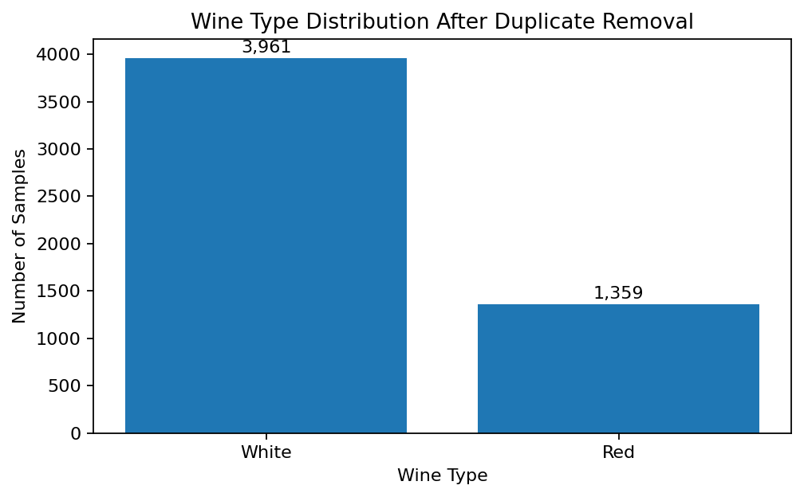
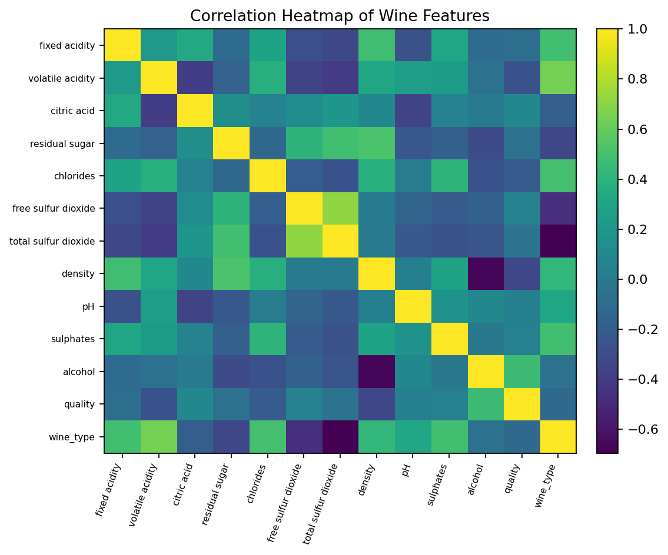

3.6 Feature Engineering and Feature Selection
No manually derived feature was required for the baseline experiment. The 11 physicochemical/quality variables were retained as predictors. The main feature preparation step was standardization because Logistic Regression and SVM are sensitive to feature scale.

3.7 Model Building and Training
Two binary classification algorithms were evaluated. Logistic Regression provides a simple linear decision boundary and an interpretable baseline. Support Vector Machine with an RBF kernel can model nonlinear boundaries through the kernel transformation. Both models use standardized features and are trained only on the training partition.

3.8 Hyperparameter Tuning
No extensive grid-search or randomized-search was performed in this baseline report. Logistic Regression uses max_iter=2000 and SVM uses an RBF kernel with scikit-learn default C and gamma settings. Systematic cross-validated tuning is listed as future work.

3.9 Model Evaluation
The models are evaluated using Accuracy, Precision, Recall, F1-score, and ROC-AUC. The confusion matrix is used to inspect the number of correctly and incorrectly classified Red and White samples.

4. Results and Discussion

4.1 Preprocessing Results
The original dataset contained 6,497 × 13 entries. After removing 1,177 duplicate rows, the working dataset contained 5,320 × 13 entries. No missing cells were present in the supplied file. The resulting dataset contained 3,961 White and 1,359 Red samples.

4.2 Model Performance
Model | Accuracy | Precision | Recall | F1-score | ROC-AUC
Logistic Regression | 0.9915 | 0.9817 | 0.9853 | 0.9835 | 0.9954
Support Vector Machine (SVM) | 0.9953 | 0.9963 | 0.9853 | 0.9908 | 0.9958
On the held-out test set, Support Vector Machine (SVM) achieved the higher accuracy at 99.53%. Its Precision was 0.9963, Recall was 0.9853, F1-score was 0.9908, and ROC-AUC was 0.9958. Logistic Regression achieved 99.15% accuracy. The high scores indicate that the supplied physicochemical measurements contain strong class-separating patterns, although performance should be validated on independent external data before deployment.
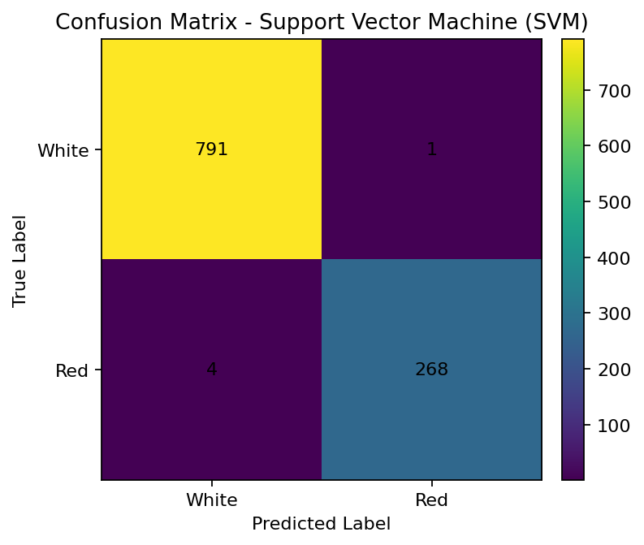
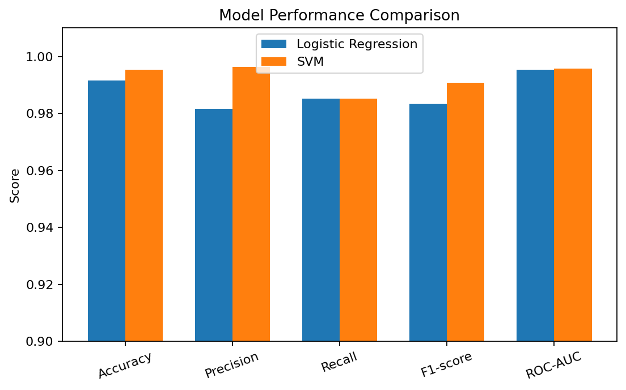

4.3 Visual Results and Discussion
The class-distribution plot shows that White wine is the majority class in the working dataset. The correlation heatmap summarizes linear relationships among the chemical variables. The confusion matrix for the stronger model shows only a small number of misclassified test samples, while the model-comparison chart shows that SVM performs slightly better than Logistic Regression on the selected test split.

5. Conclusion
This project developed a machine learning pipeline for classifying wine as Red or White from physicochemical characteristics. The supplied dataset was inspected and 1,177 duplicate rows were removed, leaving 5,320 unique observations. Two classification approaches—Logistic Regression and SVM—were trained using standardized numerical features and a stratified 80:20 train/test split. SVM produced the higher baseline test accuracy of 99.53% with ROC-AUC 0.9958. The experiment demonstrates that machine learning can distinguish the two wine categories effectively from the available measurements, while also showing the importance of preprocessing and controlled evaluation.

6. Future Work
- Perform cross-validated hyperparameter optimization for Logistic Regression and SVM.
- Compare additional classifiers such as Random Forest, Gradient Boosting, XGBoost, KNN, and neural networks.
- Evaluate class-weighted learning and other imbalance-handling methods.
- Test the models on an independent external wine dataset to measure generalization.
- Use explainable AI techniques such as SHAP or permutation importance to identify influential chemical attributes.
- Investigate whether excluding or transforming the quality feature changes the wine-type classification performance.
- Build a simple web or mobile interface that accepts physicochemical measurements and returns the predicted wine type.

7. References
[1] K. Jain, K. Kaushik, S. K. Gupta, S. Mahajan, and S. Kadry, “Machine learning-based predictive modelling for the enhancement of wine quality,” Scientific Reports, vol. 13, 17042, 2023, doi: 10.1038/s41598-023-44111-9.
[2] “Analyzing of salient features and classification of wine type based on quality through various neural network and support vector machine classifiers,” Results in Control and Optimization, 2023, doi: 10.1016/j.rico.2023.100219.
[3] “Enhancing red wine quality prediction through Machine Learning approaches with Hyperparameters optimization technique,” IEEE ICEEICT, 2023, doi: 10.1109/ICEEICT56924.2023.10157719.
[4] “Wine quality assessment for Shiraz vertical vintages based on digital technologies and machine learning modeling,” Food Bioscience, vol. 56, 103354, 2023, doi: 10.1016/j.fbio.2023.103354.
[5] O. Tigga, J. Pal, and D. Mustafi, “A Novel Data Handling Technique for Wine Quality Analysis using ML Techniques,” International Journal of Experimental Research and Review, 2024, doi: 10.52756/ijerr.2024.v45spl.003.
[6] M. A. Luthfi, A. Susanto, and R. R. Ali, “Classification of Red Wine Beverage Quality Using a Support Vector Machine Algorithm Based on Forward Selection as Feature Selection,” International Journal of Engineering Computing Advanced Research, 2024.
[7] R. Ma, D. Mao, D. Cao, S. Luo, S. Gupta, and Y. Wang, “From vineyard to table: Uncovering wine quality for sales management through machine learning,” Journal of Business Research, vol. 176, 114576, 2024, doi: 10.1016/j.jbusres.2024.114576.
[8] D. Kulasiri, S. Somin, and S. K. Pathirannahalage, “A Machine Learning Pipeline for Predicting Pinot Noir Wine Quality from Viticulture Data: Development and Implementation,” Foods, vol. 13, no. 19, 3091, 2024, doi: 10.3390/foods13193091.
[9] “An Integrated Approach Based on Fuzzy Logic and Machine Learning Techniques for Reliable Wine Quality Prediction,” Procedia Computer Science, vol. 252, pp. 613–622, 2025, doi: 10.1016/j.procs.2025.01.021.
[10] “Wine variety traceability by data fusion of near-infrared spectroscopy and mid-infrared spectroscopy combined with GAF and ResNet,” Chemometrics and Intelligent Laboratory Systems, vol. 264, 105468, 2025, doi: 10.1016/j.chemolab.2025.105468.

